Client Copy
Reflexology: BENEFITS

“Reflexology is an art and a science that deals with the principle that there are reflex areas in the hands, feet, and ears that correspond to all the internal organs, muscles, glands, and all parts of the body.”
-- Dwight Byers

A reflex by definition: An involuntary action when a stimulus is carried by an afferent (sensory) nerve to a nerve center and the response is reflected along an efferent (motor) nerve to some muscle or gland.
–Webster’s Dictionary

There are several observed or identified benefits to reflexology:
- Reduction of stress
- Improves nerve function
- Improves Circulation
- Cleanses impurities from system
- Balances the whole body
- Revitalizes Energy
- Preventative health care

Client may experience the following after a session: Deep relaxation; Gestures of pain: wincing, moaning, laughing which are all releases of tension and emotion; contraction of muscle groups due to pain;perspiration of hands/feet; sensations of being chilled/cold; deeper, calmer sleep with more dreams; increase of energy and vitality; fatigue/tiredness from toxins being released; tenderness around blocked reflex points; Healing Crisis – though this should never be radical. If a deep healing crisis is experienced, seek the support of a trusted counselor or medical professional.

Five to ten sessions bring the best overall results – each session 30-60 minutes, 48 hours between sessions. Between these sessions it is found to be helpful that the client:
  - rests
  - drinks plenty of water
  - soaks in a hot tub (with Epsom salts)
  - eats fresh veggies and fruits, goes easy on heavy proteins and fats
  - doesn’t overeat
  - does only light exercise for first 24-48 hours

(SEE OTHER SIDE FOR CONTRAINDICATONS)

Client Copy
Reflexology: CONTRAINDICATIONS
Reflexology is not Diagnosing, Prescribing, nor Treating Specific Illnesses. In the case of any of the following contraindications, the practitioner reserves the right to cancel a session.
- Contagious Diseases – Athlete’s foot, Ringworm, Warts, Rash
- Pain of an unknown source – see a doctor
- Current Fractures or recent surgery on Ankle or Foot – need Dr’s permission
- Varicose Veins – could have clots. Characterized by dilated, enlarged, twisted veins that are swollen and have incomplete valves where blood is pooling.
- Gout – acute arthritis with joint inflammation
- After an Organ Transplant – written release is required from a physician as the immunosuppressant drugs change the blood chemistry and reflexology tries to bring the blood chemistry back to normal.
- Hemorrhaging – open sores, burns, cuts, etc.,
- Inflammation – Red, hot, pain, loss of range of motion, swelling
- Severe sprains
- Tumors
- Bruises – will work around these areas
- Ingrown toenails/corns/calluses -- will work around these areas
- Medication, Drugs, and Alcohol – these substances reduce sensitivity; practitioner reserves the right to decline working with client if abuse or overuse is suspected.
- Discretion will be used for Chronic Degenerative Diseases:
  - Cancer
  - MS
  - Osteoporosis
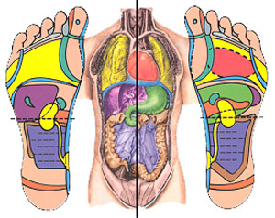

Dorsal Surface

  - Diabetes
  - Rheumatoid Arthritis

(SEE OTHER SIDE FOR BENEFITS)

Date: ___________________
Client name: ______________________________
- Has reflexology been explained to you? Yes No
- Did your therapist:
- Explain how the human body relates to areas in the feet? Yes No
- Tell you what to expect in the next 24 hours? Yes No
- Have an air of confidence and professionalism? Yes No
- Was your therapist organized? Yes No
- Were instructions given to you for after care? Yes No
- What was the quality of work on a scale of 1-10 where 1 is poor and 10 is excellent? ______
- What were your expectations of the treatment? _____________________________________
- Were your expectations met? Yes No
- What could you suggest that would improve your next session? _________________________________________________________________________________
- Did you like the depth of the work? Yes No
- Session 4 only: did you notice any changes from the first session? Please be specific. ___________________________________________________________________________________________________________________________________________________________________________________________________________________________________________________
Observations: (mark on the diagram)
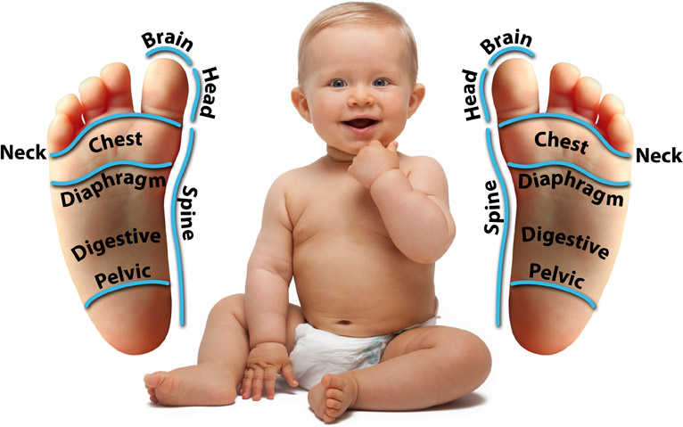
- Corn
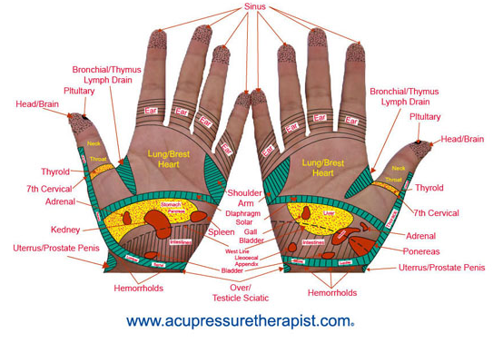
- Callus
- puffiness
- Change in tissue texture
- Unusual color or rash
- Scar from past injury
- Current injury or bruise
- Bunion
- Hammer toe
- Ingrown nail
- Wart
- Other (explain)

- Slight sensitivity or superficial tension
- Moderate discomfort
- Tolerable, but intense discomfort
- Intolerable pain
